**Muzaffer Nizam**

**Location :** Antalya, TURKEY

**Age :** 35

**Phone :** +90 536 222 90 10

**Mail :** [muzaffernizam@gmail.com](mailto:muzaffernizam@gmail.com)

**Sr. Hardware Design Engineer**

**TOTAL EXPERIENCE ( 7 Years 4 Months )**

**Personal Statement**

Before I started to Engineering Study, I quit my Mathematics education. I realized that if I am an engineer I can solve more mathematics problems. So it happened too. I love creating a solution for any problem not only working life but also all real life.

I have always wondered new things and explored to create a solution to new challenges. I am married not only to my wife but also to my job. For instance i have always helped her make the right decisions when a colleague was about to make the wrong decision at work. I've never been perfect, but I've always tried to do great things. I have always pursued real truths, not my own truths. I have always tried to apply the real truths. In the future, I will always continue to pursue the real truth in my works.

I have never been egotistical. I've always been tolerant. Maybe good things can be done alone, but more great things can be achieved with teamwork.

I am ready to new role and new life. So are your company ready to run with me?

**Education**

**Bachelor's of Science, Electrical & Electronics Engineering Oct. 2016**

**Akdeniz University**

**What do I do while I am designing Hardware;**

* I am using Altium and Kicad EDA programs in Hardware Designs. If it is small project and which contains low speed signals I prefer Kicad, if it is big project and which contains high speed signals I prefer Altium Designer.
* Pin assignment with STM32CubeIde or CubeMX according to role such as communicating, input, output, PWM, Analog etc for to prepare Low level driver and to design schematic (if I use STM32 MCU family)
* Design Compliant with IPC2221 Electrical Conductor Spacing Standards and EMC Standards,
* Design Compliant with different density Via dimensions of IPC-2221,
* Design Compliant with different Environmental Temperatures and Pressures Track width
* Multi layer PCB Designs 2,4 and more Layers,
* Flex and Poly-amide PCB Design,
* Design compliant with BGA components
* Choosing different temperatures density PCB Materials such as FR-4 TG 130-140, TG 170 etc,
* Various Analog and Digital Circuit Design with 32 bits ARM Core and 8 bits STM 8 Core MCUs such as STM32xx, CC13xx Ti, TM4Cxx Tiva Series MCUS, NXP MCUs etc.
* Power Circuit Designs Such as Switching Regulators or Switching Controllers
* Motor Control Drivers Designs such as Brushed DC, BLDC, PMSM etc
* Digital Designs SPI, I2C, DAC, RS485, UART, Ethernet, CAN Bus isolated or non isolated.
* Wireless Communication Designs GSM, GNSS, Bluetooth, RF Sub 1 Ghz, Wifi,
* System Modelling, simulating and analyzing with Matlab Simulink,
* Analog Designs ADC, DAC, FSK Communication on Power Line, various OP-AMPS Gain Calculating, Analog Filters Designs,
* Simulate with LTSpices, Measurements with Oscilloscopes adding to Reports documents
* Environmental Test such as Temperature test, Pressure Test, ESD Gun Test,
* Creating PBA and PCB Production Files such as Gerber Files, Pick and Places Files, DXF and Step files for Mechanical Designs,
* Layer Stack Management,
* Controlling with GERBV (free Gerber viewer),
* Prepare Bill of Materials List,
* Version Control with github,
* Short Circuit Testing,
* Voltage Level Testing,

**What do I do while I am designing Firmware ;**

* Code Generation with STM32CubeIde,
* Low level driver preparing such as below,
* UART/USART Communication Firmware Testing,
* Can Bus Communication Firmware Testing,
* SPI, I2C and RS485 Communication Firmware Testing,
* ADC Input Firmware Testing,
* DAC Output Firmware Testing,
* PWM Generation Firmware Testing,
* General Input detect and Output Control Check Firmware Testing even including Interrupts,
* Hardware Verification with Firmware.

**Interested In Below;**

* VHDL Design,
* Motor Control Applications with FOC algorithms,
* PID algorithms,

**JOB EXPERIENCES**

1. **Electrical & Electronics Engineer Intern ( 3 Months)** June 2013- September 2013

**Company:** Turkcell Communication A.Ş.

**Website: <https://www.turkcell.com.tr/>**

**Job Type:** Intern / Full Time

**Reason for Leaving:** Intern Finished

**Job Deification:**

* GSM Base Station Location Planning,
* Various Technical Calculating,
* Field operations.

1. **Electronics R&D Engineer ( 2 Years 4 Months)** August 2015- October 2017

**Company:** Desird Tasarım Arge Uygulama Elekt. Des. İth. İhr. San LTD ŞTİ

**Website: <https://desird.com/>**

**Job Type:** Permanent/Full Time

**Reason for Leaving:**Military Status

**Job Deification:**

**Hardware Designed below projects;**

* Biomedical Electronic Card Designs
* Elevator DC Door Control Driver Board Designs
* IOT Card Designs
* Telemetry Card Designs communication with FSK on DC Power Line
* Main Board Designed which is communicating with Telemetry Cards,
* Test Machine Design contains with Pogo Test Probe Tips
* In addition in relevant projects doing Hardware Designs(Schematic and PCB), Measuring, Reports and Tests,
* Designed with STM32xx, CC13xx Ti MCU’s, PIC18xx MCU’s

1. **Electronics R&D Engineer ( 2 Years 10 Months)** May 2018- February 2021

**Company:** Desird Tasarım Arge A.Ş. (Same Company previous one, but Commercial Title of Company changed)

**Website: <https://desird.com/>**

**Job Type:** Permanent/Full Time

**Reason for Leaving:**Resignation

**Job Definition:**

**Hardware Designed below projects;**

* Elevator BLDC Door Control Driver Board Designs
* IOT Card Designs
* Test Equipment Design contains with Pogo Test Probe Tips
* Railway BLDC Door Control and Safety Boards which has Safety Relay and compatible relevant SIL Certificate,
* In addition in relevant projects doing Hardware Designs(Schematic and PCB), Measuring, Reports and Tests,
* Designed with STM32xx, STM8xx, NXP MCU’s, PIC16xx MCU’s

1. **Electronics R&D Engineer ( 1 Years 2 Months)** February 2021- April 2022

**Company:** Ake Elevator and Escalator LTD

**Website: <https://ake.com.tr/>**

**Job Type:** Permanent/Full Time

**Reason for Leaving:** Company created another Company as for Electronics R&D called Acri Industrial LTD ŞTİ

**Job Definition:**

**Hardware Designed below projects;**

* Elevator DC Door Control Driver Board Designs
* Remote control with GSM Communication Card Designs
* Various Elevator Control Boards Designs,
* Water Vending Control Boards Designs,
* Elevator Main Control, Cabin Buttons Boards, Top and Bottom of Cabinet Boards, Floor Calling Boards which is communicating with CAN Bus and DC and AC signal Lines,
* In addition in relevant projects doing Hardware Designs(Schematic and PCB), Measuring, Reports and Tests,
* Designed with TM4Cxx Ti, MSP432xx ARM Core, MSP430xx Ti

1. **Electronics R&D Engineer ( 9 Months)** April 2022 - Still Working

**Company:** Acri Industrial LTD ŞTİ

**Website: <https://www.acritechnology.com/>**

**Job Type:** Permanent/Full Time

**Reason for Leaving:** Low Salary and Economic Problems in Turkey, Turkish Lira currency lose, Inflation on Turkey.

**Job Definition:**

**Hardware Designed below projects;**

* Elevator DC Door Control Driver Board Designs
* Remote control with GSM Communication Card Designs
* Various Elevator Control Boards Designs,
* Elevator Main Control, Cabin Buttons Boards, Top and Bottom of Cabinet Boards, Floor Calling Boards which is communicating with CAN Bus and DC and AC signal Lines,
* Test Machine Design contains with Pogo Test Probe Tips
* In addition in relevant projects doing Hardware Designs(Schematic and PCB), Measuring, Reports and Tests,
* Designed with TM4Cxx Ti, STM32xx,

**Personal Design Project and designed by me;**

* It is called STM32 Mega Development Board
* Contains Technologies as a below;
* 24V AC or DC Power Input,
* 2 different Switching Regulator GSM and General System Power as 4.3V and 5V,
* Controlling GSM Power with XOR Gate and Transistor,
* Analog Bus Voltage Read with Buffer op amp,
* DAC Output,
* Voltage levels are 24V, 15V, 5V, 4.3V,3.3V,
* USART communication with USB Mini also contains Programming,
* CAN Bus Communication,
* RS485 Communication,
* SPI and I2 Communication connected to Connectors,
* SD Memory Card communicated with SPI Interface,
* 16x2 Character LCD Display communicated with I2C Interface,
* FLASH Memory communicated with I2C Interface
* Non-Isolated Signal Input,
* Darlington Output with ULN2004 IC,
* Linear Potentiometer Analog Read,
* Between Range of 0V to 600V DC Voltage Read with op amp,
* Between Range of 0-10A Current Read with op amp,
* Short Circuit Detection,
* DC and BLDC Motor Control Driver Circuit with Back EMF Current Reading,
* Encoder Input (Absolute and Incremental)
* 16 Channel Isolated Input detected with Shift Register Input,
* Accelerometer (ADXL345 IC) communicated with SPI,
* 4 Buttons for LCD Controlling,
* 24V Relay Output (SPDT 1 FORM C),
* SIM800C GSM Modul communicated with SPI Interface

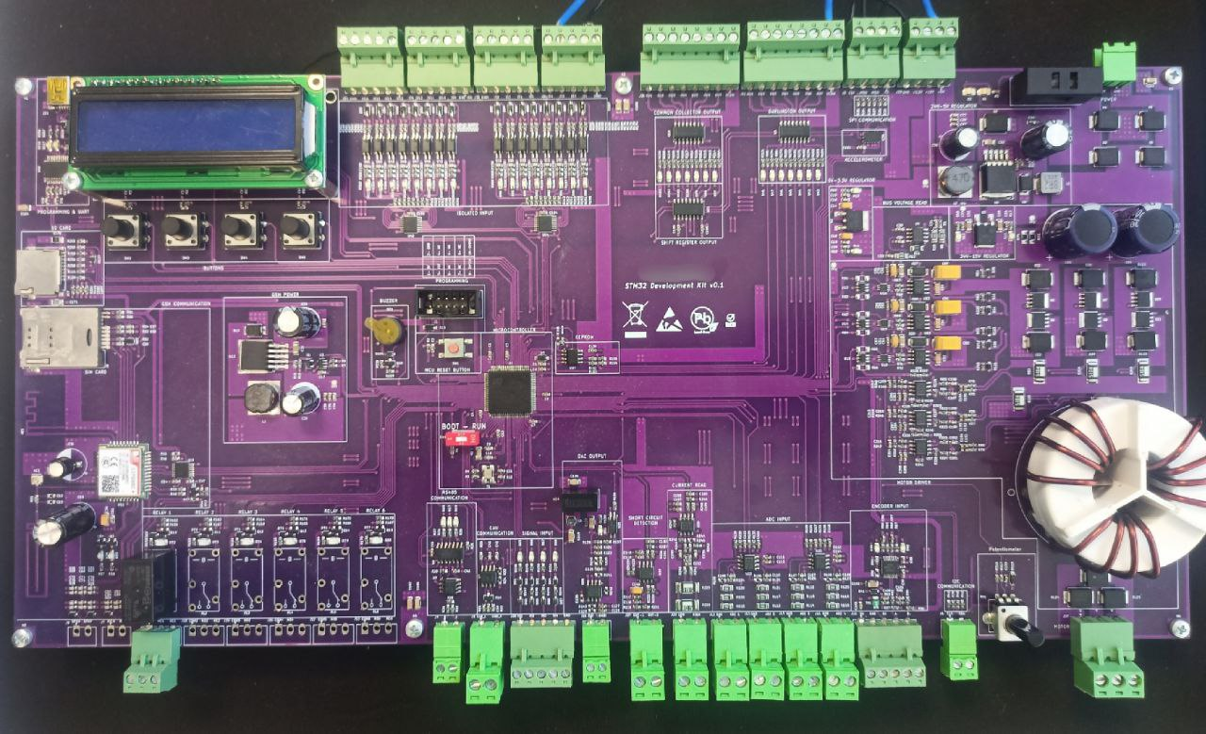

Figure 1 : STM32 MEGA Development Board

**Foreign Language**

* English Level : B2-Upper Intermediate (Preparing School of University & English Culture Course in Antalya )

**Certificates**

* Safety Integrity Level for RAILWAY SYSTEM ELECTRONICS - **TUV NORD** April 2019
* Humanoid Robots Industrial Automation - **ENTEK EDUCATION TECH.** December 2012

**Hobbies**

* Latin Dances Salsa & Bachata
* Taking Photo
* Cats and Dogs
* Flying a Kite